Sample Syllabus:

English 5664

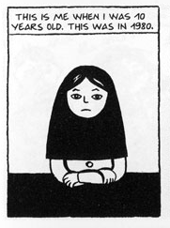 | Graphic History:  Memory, Identity,  &  comics | 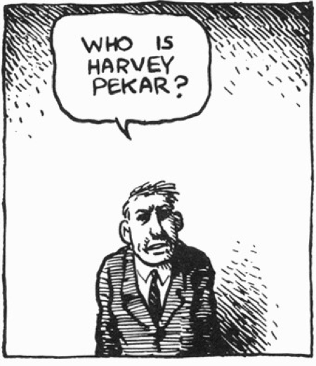
Prof. Jared Gardner  530 Denney  gardner.236@osu.edu | http://people.cohums.ohio-state.edu/gardner236 | Office hours  T 9:30-11, W 1:30-2:30  & by appointment

SCHEDULE

Week 1

R Introductions: graphic narrative, memoir and history

Week 2

T Autobiography and underground comix (1975-1975)

R Justin Green, Binky Brown Meets the Virgin Mary (1972)

Supplementary readings (primary): Zap Comix #1; Nakazawa, Barefoot Gen

Supplementary readings (essays): Gardner, “Autography’s Biography”

Week 3

T Spiegelman, Maus (Vol 1); McCloud, Understanding Comics, chap. 1

R Spiegelman, Maus (Vol 1)

Supplementary readings (primary): Spiegelman, “Maus” (first story version); Eisner, Contract with God

Supplementary readings (essays): Wilner, "Happy, Happy Ever After"; Hirsch, “Surviving Images”

Week 4

T Spiegelman, Maus (Vol 2)

R Spiegelman, Maus (Vol 2)

Supplementary readings (primary): Spiegelman, In the Shadow of No Towers

Supplementary readings (essays): Ewert, “Art Spiegelman's Maus and the graphic narrative”; Levine, “Necessary Stains”; McGlothlin, “No Time Like the Present”

Week 5

T Pekar, American Splendor; McCloud, Understanding Comics, chapter 2

R Pekar, American Splendor

Supplementary readings (primary): Kominsky-Crumb, autobiographical stories; Pekar, American Splendor comicbook ; Our Cancer Year; The Quitter; American Splendor [the movie] (2003)

Supplementary readings (essays): Witek, “’You Can Do Anything with Words and Pictures’”; Hatfield, “’I Made the Whole Thing Up’”; Sperb, “Removing the Experience”

Week 6

T Phoebe Gloeckner, A Child’s Life; McCloud, Understanding Comics, chapter 3

R A Child’s Life; on-line anthology of autobiographical stories

Supplementary readings (primary): Gloeckner, Diary of a Teenage Girl; Barry, One Hundred Demons; Chester Brown, I Never Liked You; Wimmen’s Comix

Supplementary readings (essays): Whitlock, “Autographics”; Hatfield, “An Art of Tensions”; Mitchell, “Beyond Comparison”; Gilmore, “Limit-Cases”

Week 7

T Bechdel, Are You My Mother?; McCloud, Understanding Comics, chapter 4

R Are You My Mother? (continued)

F 10/19 Paper 1 due

Supplementary readings (primary): Bechdel, Dykes to Watch Out For; “Coming Out Story”; Fun Home

Supplementary readings (essays): Chute, “Interview with Alison Bechdel”; Watson, “Autographic Disclosures and Genealogies”; Cvetkovich, “Drawing the Archive”

Week 8

T Ware, Jimmy Corrigan; McCloud, Understanding Comics, chapter 5

R Jimmy Corrigan (continued)
Supplementary readings (primary): Ware, Acme Novelty Library; Quimby; “Building Stories”; Brunetti, autobiographical and biographical stories; Deitch, Boulevard of Broken Dreams

Supplementary readings (essays): Bredehoft, “Comics Architecture, Multidimensionality, and Time”; Ryan, “Introduction”; Kannenberg “The Comics of Chris Ware”; Baetens, “Comic Strips and Constrained Writing”; Prager, “Modernism in the Contemporary Graphic Novel”

Week 9

T Lutes, Berlin; McCloud, Understanding Comics, chapter 6

R Berlin (continued)

Supplementary readings (primary): Lutes, Jar of Fools; Berlin (the story continues); Moore, From Hell; Bendis, Torso; Katchor, Jew of New York; Brown, Louis Riel; Sturm, The Golem’s Mighty Swing

Supplementary readings (essays): Benjamin, “The Work of Art in the Age of Mechanical Reproduction”; Crary, “Modernizing Vision”; Simmel, “Metropolis and Mental Life”; Gardner, “Archives, Collectors and the New Media Work of Comics”

Week 10

T Satrapi, Persepolis

R Paper 2 due

Supplementary readings (primary): Satrapi, Embroideries; Chicken with Plums; Hernandez, Palomar

Supplementary readings (essays): Davis, “A Graphic Self”; Chute, “Memory and the Ordinary Self”; Tensuan, “Comic Visions and Revisions”; Hirsch, “Testimonial Objects”

Week 11

T David B., Epileptic

R Epileptic (continued)

Supplementary readings (primary): David B., Babel; Dupuy and Berberian, Maybe Later

Supplementary readings (essays): Groensteen, “Restrained Arthrology: The Sequence”; Jacobs, “More than Words”; Green, “Graphic Medicine”

Week 12

T Sacco, Footnotes in Gaza; McCloud, Understanding Comics, chapter 7

R Footnotes in Gaza (continued)

Supplementary readings (primary): Sacco, Safe Area Gorzade; Palestine; Delisle, Pyongyang; Modan, Exit Wounds; Pekar et al., Macedonia

Supplementary readings (essays): Chute, “Drawing to Tell”; Dolezel, “Fictional and Historical Narrative”; Wolf, “Cross the Border”; Baetens, “Revealing Traces”

Week 13

T Footnotes in Gaza (Concluded)

R NO CLASS (THANKSGIVING)

Week 14

T Tomine, Shortcomings

R Shortcomings (continued)

Supplementary readings (primary): Yang, American Born Chinese; Tomine, Optic Nerve; Yang, Same Difference

Supplementary readings (essays): Park, “Lost in the Gutters”; Gardner, “Same Difference”

Week 15

T Final project presentations

R Final project presentations (continued); Conclusions

R Paper 3 due

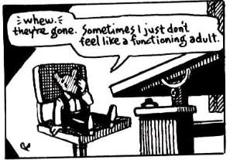 | 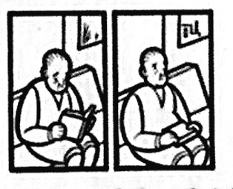

BOOKS

Available at the SBX & The Laughing Ogre

1. Spiegelman, Art. Maus : A Survivor's Tale : My Father Bleeds History/Here My Troubles Began [Boxed Set] (Pantheon)
2. Pekar, Harvey. American Splendor: The Life and Times of Harvey Pekar (Ballintine)
3. Gloecker, Phoebe. A Child's Life (Frog)
4. Bechdel, Alison. Are You My Mother? (Houghton Mifflin)
5. Ware, Chris. Jimmy Corrigan: The Smartest Kid on Earth (Pantheon)
6. Lutes, Jason. Berlin: Book One (Drawn & Quarterly)
7. Sacco, Joe. Footnotes in Gaza (Metropolitan Books)
8. Satrapi, Marjane. Persepolis Boxed Set (Pantheon)
9. David B. Epileptic (Pantheon)
10. Adrian Tomine, Shortcomings (Drawn & Quarterly)
11. McCloud, Scott. Understanding Comics (Harper)

RESPONSIBILITIES

a. readings
We will be reading extensively in contemporary graphic narratives, as well as in theory and practical inquiry into the structure and interpretation of sequential graphic narrative and other text/image hybrid forms. All readings are to be completed for the class in which they are scheduled.

Each week also lists supplementary primary and secondary/theory reading. I hope that you will be able to look at as many of these as possible; all students are required to read at least one of the primary texts each week, and graduate students are also required to read at least one of the secondary essays each week. All of the essays are accessible at the class’s Carmen site. The primary readings are available on closed reserve at the Cartoon Research Library (see LIBRARIES below) and, in many cases (not all) online at the class’s MediaManager site, accessible through Carmen (READINGS).

There will also be additional materials accessible via the class’s Carmen site, designed to provide history and context for the graphic narratives we are studying (see Carmen below).

b. writing/presentations

Everyone will be writing three papers (for undergraduates, 2 3-4 pages and 1 5-7 pages; for graduate students: 2 5-7 pages and 1 10-15 pages). Detailed instructions and discussion of the expectations for each paper will be given 3 weeks before each paper’s due date. The final paper can build upon the work begun in one of the earlier short papers.

c. discussion
This is a seminar class in which we are working collaboratively from our varied perspectives, experiences and insights to answer some of the big challenges involved in this emerging field. Discussion will be a required component of the class. While I will give mini-lectures here and there to provide some history and background, or to lay out some new theoretical problems for us to work through, the bulk of the work we will be doing together. Toward that end, you will need to come each day with notes, questions, insights--and energy to share all of the above.

In lieu of exams, quizzes, etc. and as a resource for our own writing and a foundation for discussion in class, each of us will also maintain a regular online “reading notebooks,” which will be posted to the Carmen site. Each student is expected to post regularly to the Carmen site, offering thoughts about the central reading (NOTE: graduate students are required to post one notebook entry each week on one of the supplementary texts) for the week, outlining some general questions, offering some initial connections or insights, responding to the thoughts, questions, insights of others in the class etc. Contributions (or lack thereof) to Carmen discussion will be factored into your grade (see below).

d. Carmen
To get to the course site, go to http://carmen.osu.edu and follow the directions from there (detailed "Getting Started" instructions can be found at the end of this syllabus). This will be the space where announcements, links, supplementary texts, discussion forums will be found. I will be adding to this site throughout the term, and you will be adding as well. The immediate requirements with which you need to familiarize yourself are:

- DISCUSSIONS (stop by and introduce yourself if you haven’t already)
- READINGS: primary and secondary materials related to graphic narrative and related theories and intellectual problems.
- LINKS: miscellaneous background materials and resources to supplement your study of this fascinating and challenging material.

e. attendance
Given the pace of our readings and the collaborative nature of our work, a strict attendance policy will be enforced. Each absence more than 2 will reduce your final grade by a half letter grade (for example, from B+ to B).

f. grading
The formula for the class is:
papers=20%, 20%, 30%, Carmen=10%; participation/attendance=20%

g. academic honesty
Plagiarism is the representation of another's works or ideas as one's own: it includes the unacknowledged word for word use and/or paraphrasing of another person's work, and/or the inappropriate unacknowledged use of another person's ideas. All cases of suspected plagiarism, in accordance with university rules, will be reported to the Committee on Academic Misconduct.

It is the responsibility of the Committee on Academic Misconduct to investigate or establish procedures for the investigation of all reported cases of student academic misconduct. The term “academic misconduct” includes all forms of student academic misconduct wherever committed; illustrated by, but not limited to, cases of plagiarism and dishonest practices in connection with examinations. Instructors shall report all instances of alleged academic misconduct to the committee (Faculty Rule 3335-5-487). For additional information, see the Code of Student Conduct.

i. students with disabilities
Students with disabilities that have been certified by the Office for Disability Services will be appropriately accommodated and should inform the instructor as soon as possible of their needs. The Office for Disability Services is located in 150 Pomerene Hall, 1760 Neil Avenue; telephone 292-3307, TDD 292-0901. http://www.ods.ohio-state.edu

RESOURCES AND LIBRARIES

There is no place in the world better for the study of comics and the graphic novel than Ohio State, thanks to the Billy Ireland Cartoon Library & Museum (http://cartoons.osu.edu), the biggest and best special collection devoted to the form, and to the vibrant comics culture here in central Ohio (the Buckeye state has produced more presidents and comics creators than any other state: if anyone can figure out how the two are connected, let me know). On top of that, our public library system is terrific, and has a large collection of graphic narrative titles (if you don’t already have a public library card, get one; you can order your books online and have them sent to your local branch for pickup: http://columbuslibrary.org).

Some titles are circulating in the OSU Libraries, and others can also be requested via OhioLink. With a little planning, there is almost nothing you can’t find here in Columbus.

There are several good neighborhood bookstores for graphic narratives and comics. The Laughing Ogre (4258 North High Street) remains the best in the city, and they will be carrying our titles if you wish to buy the course books there. They also have the best collection of monthly mainstream and alternative comics in the city (closely rivaled by Comic Town (1249 Morse Rd.). Closer at hand, the Wexner Bookshop has a small but well-selected collection of graphic novels. Online, your best prices will often be found at the big dealers, like amazon, although you can often find good used copies at decent prices at half.com and powells.com.

